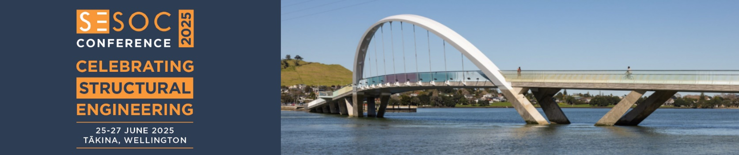
SESOC ESE Scholarship Application Form
Application form for the SESOC ESE Scholarship to attend the SEAOC 2027 Annual Conference in Monterey, California.
This scholarship will be awarded to a SESOC Emerging Structural Engineers (ESE) Network member and will provide for the recipient to travel to, and present their paper at, the SEAOC 2027 Annual Conference in Monterey, California.
Applications will be judged based on the full paper submission and the responses to the questions below.
The criteria for the ESE Scholarship:
- Typically, Emerging Structural Engineers are considered to have less than 10 years’ experience as a structural engineer. Consideration is given to career breaks and parental leave.
- Must be a SESOC Member as of 30 April 2027.
- Must have joined the SESOC ESE Network as of 30 April 2027.
- Must attend and present their paper at the 2027 SESOC Conference in Auckland.
- Must be available and able to travel to the SEAOC 2027 Annual Conference from 25-27 August 2027 in Monterey, California. Travel dates to be advised.
- Applications will be judged by a panel of SESOC and SEAOC members.

Name:

Company:

Email Address:

Years in Structural Engineering:

Title of Paper:

- Why did you choose to pursue a career in structural engineering?

- What is your current involvement or interest in SESOC, and how do you see yourself being involved in SESOC in the future?

- Why are you interested in attending the SEAOC Conference and what do you hope to gain by conference involvement?

Note: Answers to be limited to one page

